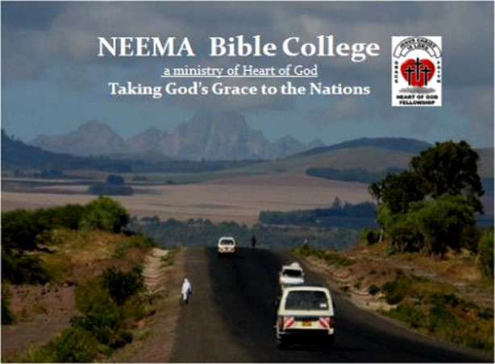
NEEMA Bible College
Student Application

FOR COLLEGE USE ONLY
Date Received: ________
Fee Received: _________
Student ID #__________

Attach Your Passport Photo to This Area

Names:
Mailing Address:
Email Address:
Mobile Phone:
Personal Information: Female Male

Date of Birth:
Marital Status: Single Married Separated Widowed

If Married, Name of Spouse:
Is Your Spouse Supportive of You Attending NEEMA Bible College? Yes No

Children: Name: Age:
Children: Name: Age:
Children: Name: Age:
Children: Name: Age:
Spiritual History: When did you accept Jesus Christ as your Savior?
Name of Church/ Denomination:

Educational History: Primary Secondary Class Completed:

College/University Course Studied: Degree Earned:

Other: Course Completed: Date:

Name of Present Employer:

Will you be taking time off work to attend class? Yes No
Ministry Experience: Briefly explain what your duties and responsibilities are in ministry:

I certify to the best of my knowledge that all the answers and statements on this application are true and give an accurate account of my background.
Signature: ________________________________________________ Date: _________________
Please note: If you are filling this form out on a computer or mobile device, the signatures needed will be captured when you see a NEEMA Bible College staff member in person.

Below are three essay questions that will help us evaluate you as an applicant. Please answer them as completely as possible.
1. Why do you want to attend NEEMA?

2. Write a brief description of your relationship with God:

3. How did you learn about NEEMA?

4. How do you plan to pay for your fees at NEEMA Bible College?

I (type your full name here) do hereby acknowledge that the management or staff of NEEMA Bible College has explained that the acceptance and graduation from NEEMA Bible College does not in any way mean or convey to me that anything other than a diploma has been offered. It is further understood that no promise of a position or employment of any kind has been offered or promise or will it be. All employment will be according to the needs of the college and/or Heart of God Fellowship Ministry Kenya, according to the will of God as understood and confirmed to the staff and management on NEEMA Bible College and Heart of God Fellowship Ministry Kenya.

Signed ____________________________________________ Date_______________

Signed __________________________________ Date ______________
Founder NEEMA Bible College

Please note: If you are filling this form out on a computer or mobile device, the signatures needed will be captured when you see a NEEMA staff member in person.

